Call-Out: Subsidised Studio Resident

We are looking for an artist, at any stage of their career, who identifies with needing a subsidised studio space.

It might be that you are:

- A young artist.
- A recent graduate.
- Five years into your professional career and studio space is still out of your price range.
- A mid career artist without formal education, which has been working against you.
- Beginning to practice as an artist again, later in life, and not being offered space.
- An artist whose identity (race, gender, rejection of gender, sexuailty etc) has been working against you to access studio space.
- Or maybe another reason.

This call-out aims to offer very cheap artist space to those who do not have access to one and an opportunity to embed yourself amongst a community of professional visual artists at Jamaica St Studios.

It is important that you are applying because at this point in your professional development and career you have very little means to find yourself a studio space in Bristol. If you already have a studio space or have the financial means to get one, please do not apply.

Please note: This was formerly called the Young Artist & Recent Graduate residency, and is still in its pilot stage. This will be the second time we undertake this.

If you would like to apply, please read the information below carefully. If you have any questions, please contact our studio manager Danny on studio@jamaicastreetartists.co.uk.

INFO

What is Jamaica St Studios?

Jamaica St Studios is one of the largest artist-led studios outside of London and has been established for over 20 years. It is a creative community in the heart of Bristol that makes, exhibits and collaborates – locally, nationally and internationally.

With over 30 artists working across three floors, our site is a place of production for a range of practices: painting, installation, drawing, paper cutting, doll making, printing, illustration, filmmaking and more.

Studio Space:

We are offering you your own studio space. The studio space is part of Jamaica St Studios, 39 Jamaica Street, Stokes Croft, Bristol. Our studios are not wheelchair accessible.

This space is on the 2nd floor and is an open space. By open space, we mean that this studio is adjacent to a corridor, isn’t fully enclosed by walls and does not have a door. You will have to be happy to work in a non-private space. This will be very easy because everyone on the 2nd Floor is lovely!

The space is approximately 2.5m in length and 2.2m in width. It includes three white walls to work on and comes with a desk. A small part of the space is made up of a current artist’s storage space.

You will have access to WiFi.

Please bear in mind the description of the space when applying. Please only apply if the studio space we are offering will be appropriate for your artistic practice. You will have an opportunity to fully see the space, if you are invited to an interview.

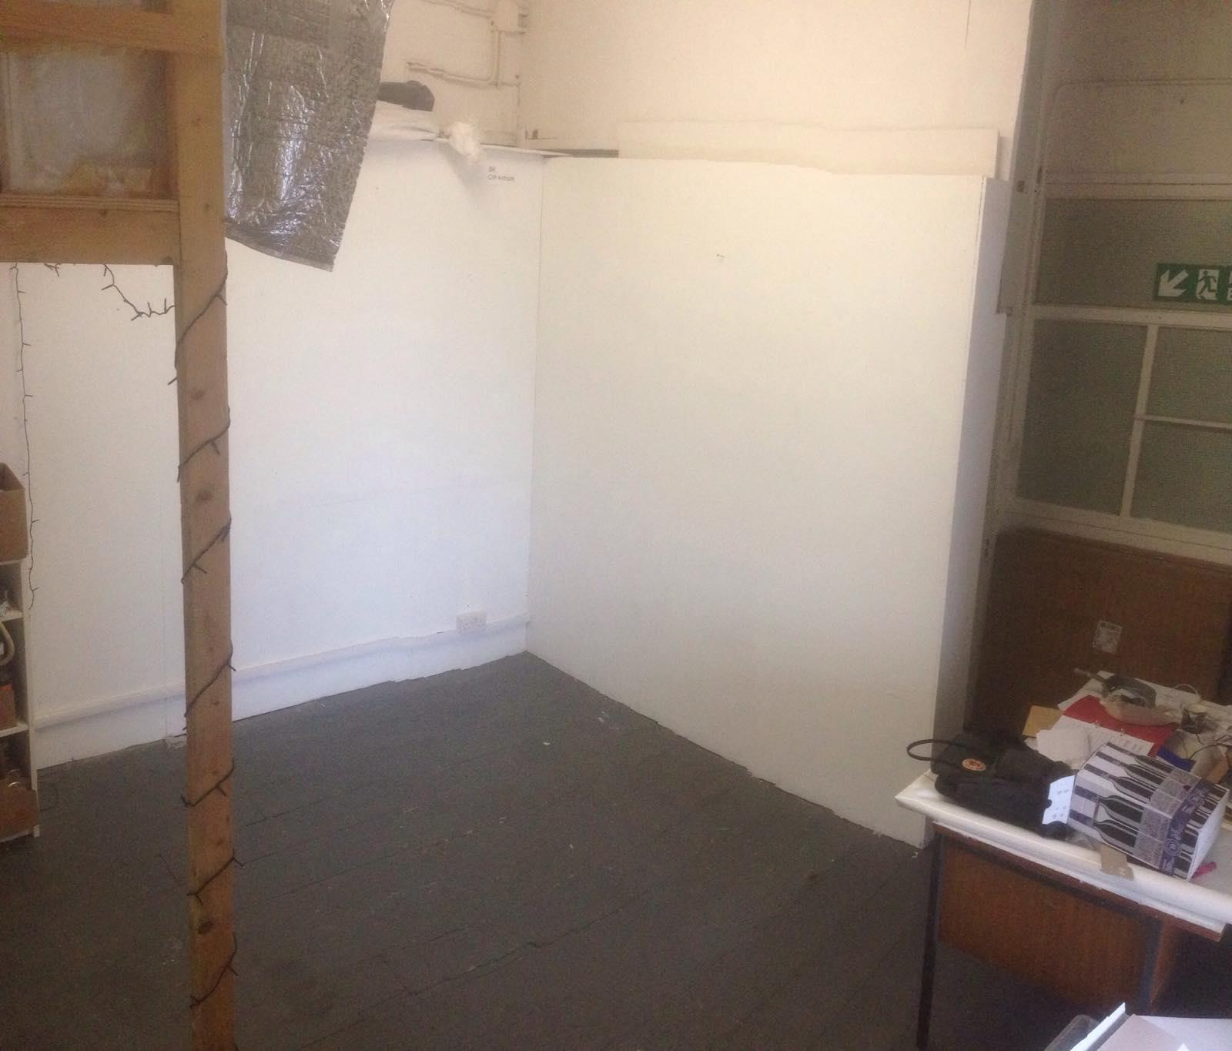

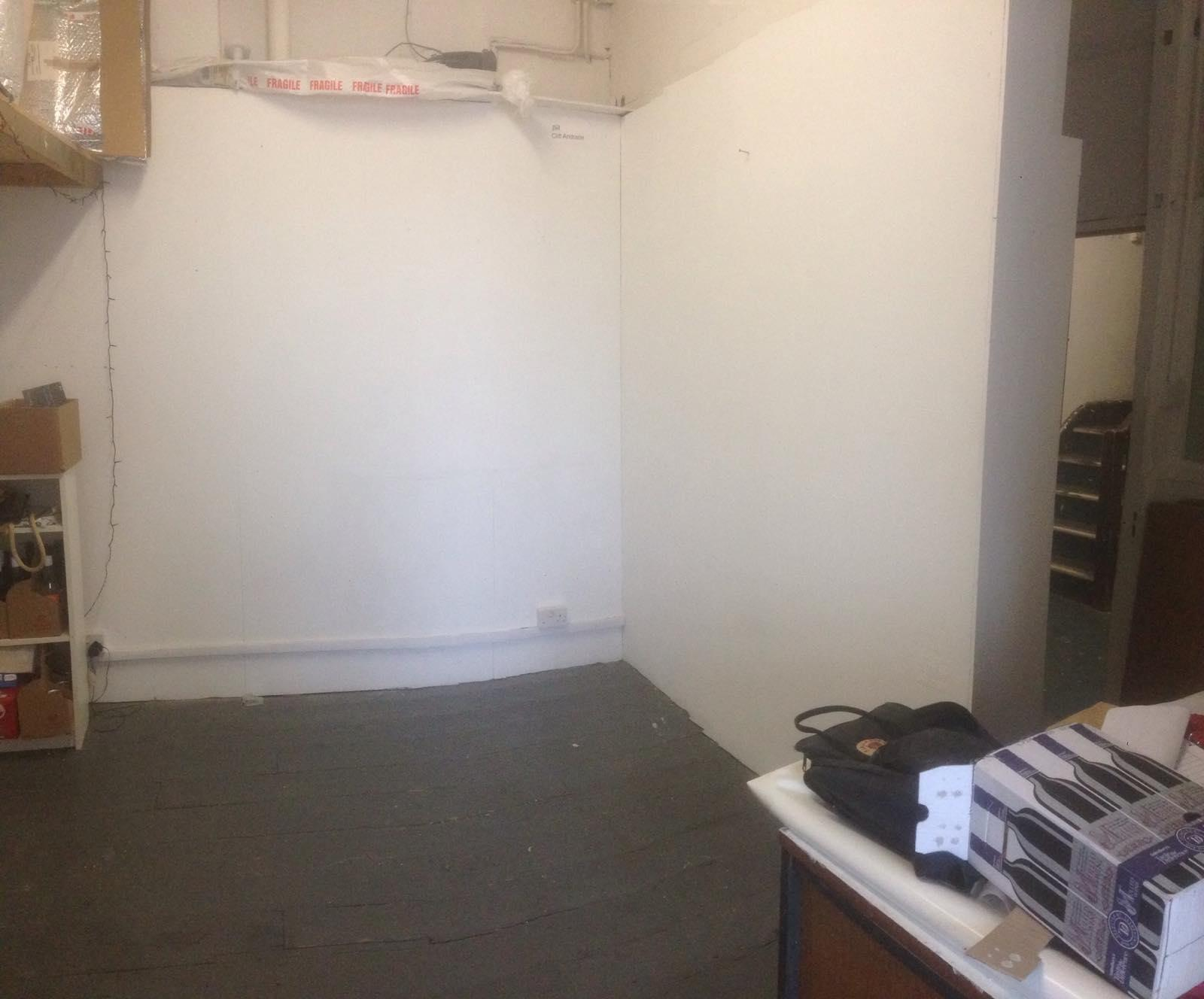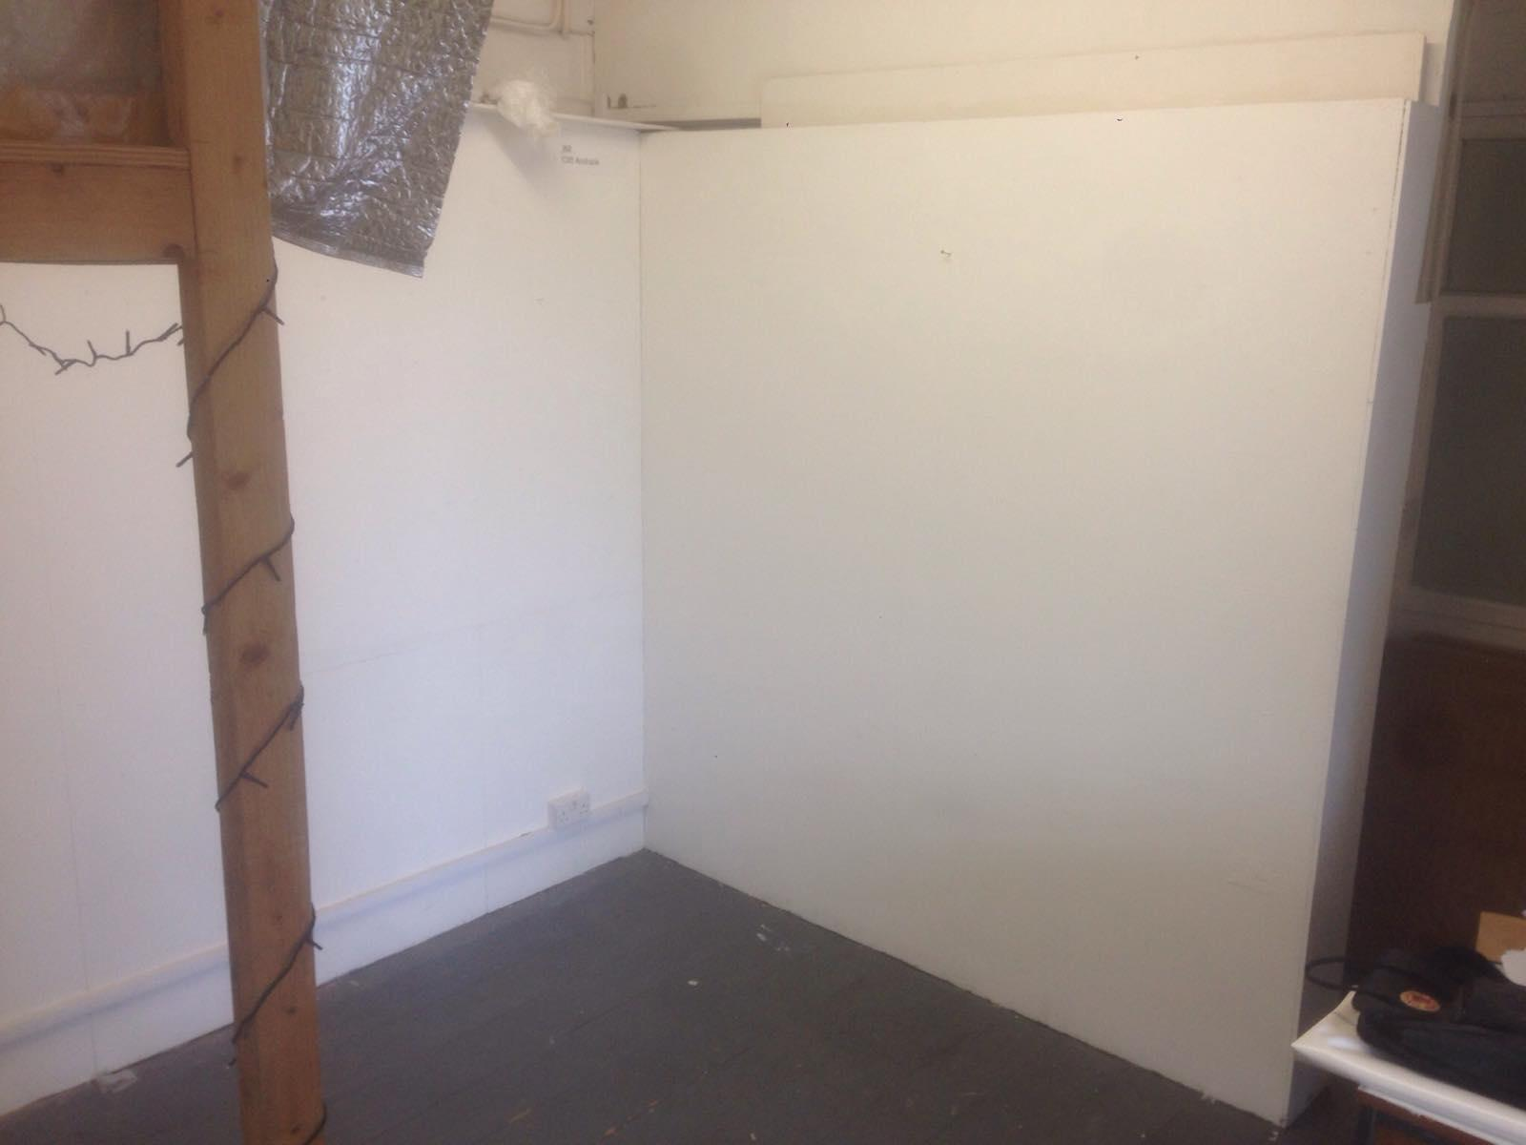

Price:

Full rent of this studio space is £31.50 per month, this includes all utilities. The rent for this space is subsidised by 50%.

Length of offer:

We are offering this space on a 6 month contract. Your time with us will begin on 2nd September 2019 and end on 28th February 2020.

Expectation:

We expect you to use your studio at least 2 days a week on average.

We will expect that you will have an artistic project to begin or continue during your residency with us. This can be anything e.g. experiments, multiple works, a longer investigation in a new form etc.
We expect you to be part of the Jamaica St Studio community and abide to the same commitments as the other studio artists e.g. attend meetings, contribute to fundraising events etc.

To be transparent, our offer to you is a space and an opportunity to work alongside Jamaica St Studio artists. Beyond that, it is completely led by you. We invite you to propose other things you might like to do during your time with us. You will have access to support from our studio manager in making these things happen.

Application Process:

If you would like to apply then please send back this document with the below questions answered. Please write no more than one page.

Important: please send six images of your work along with your application.
Please send back a complete application form and images to studio@jamaicastreetartists.co.uk. When you save your application form please rename the file to include your full name. When you email please put in the subject line: ‘SSR App’.

Deadline: Friday 2nd August, 5pm.

If you are successful you will be invited to an informal interview with a few studio artists.

Interviews will be held the week commencing 19th August.

APPLICATION

Name:

Age:

Email:

Phone number:

Website (if you have one):

Who are you and what do you do?

What will you be working on during your time with us?

Please let us know why access to a subsidised studio space would be important to you at this point in your professional development & career?

